Reading – Year 2
Autumn
Main Text | 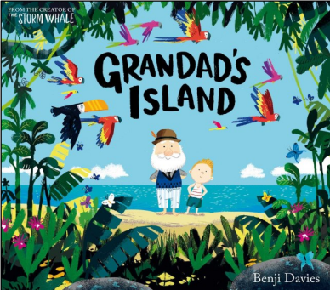 | 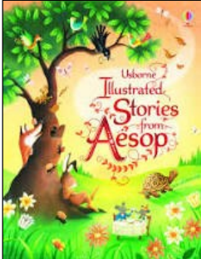 |  | 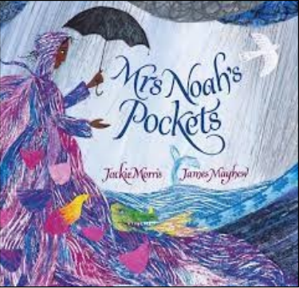 | 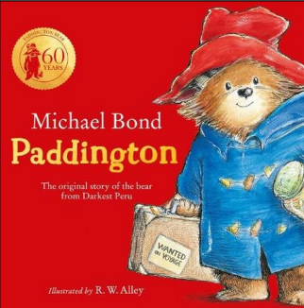 | 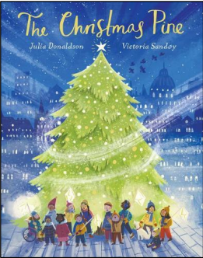
Genre | Fiction – family relationships | Fables Anthology |  | Fiction – inclusion, diversity, uniqueness. | Fiction | Poetry
Pupils will know: | Information can be retrieved from text and illustrations.  Inferences can be made from the gaps in information. | A synonym is a word that means the same as another word.  Inferences need to be supported with clues from the text. |  | Summaries can take many forms.  Inferences need to be supported with evidence from the text. | Summaries can take many forms including a written summary, notes, tables and pictures.  Emotions can be conveyed through facial expressions.  Questions contain key words that help you understand what is being asked.  Actions are usually performed for a reason. | Poems are organised in verses.  Solving riddles is a form of inference.
Pupils will be able to: | Retrieve actions from a text to perform them.  Make inferences from what is not said. | Find and copy words with a similar meaning.  Select best evidence to support a given inference. |  | Inferences need to be supported with evidence from the text.  Select specific evidence to support a given inference. | Use a sketch to summarise a section of text.  Infer characters’ feelings through gestures and facial expressions.  Identify key words in the question to support finding the answer in the text.  Infer the reasons for characters’ actions. | Match a summary to the relevant section of text. Use what they read as stimulus for their own ideas.
Spring
Main Text | 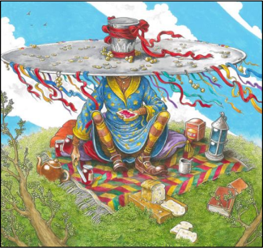 | 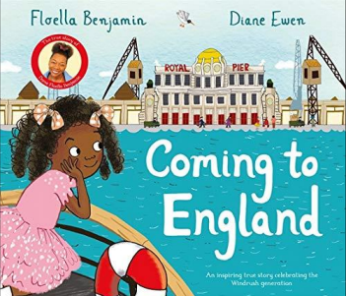 |  | 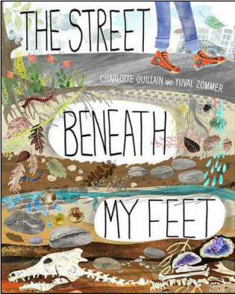 | 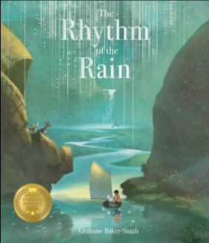 | 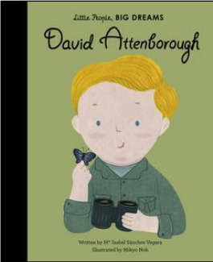
Genre | Poetry - Nonsense | Non-Fiction - Biography |  | Non-Fiction | Non-Fiction – water cycle | Biography
Pupils will know: | A nonsense word is a made-up word.  The meaning of words can be inferred using the words around them. | Predictions can be supported with text, titles and illustrations.  The meaning of words can be inferred using the words around them. |  | Organisational devices can support locating facts easily. Inference means making a conclusion from clues given. | Illustrations add extra detail and meaning.  Mood can be inferred from the writer’s language choices.  Non-fiction texts can include illustrations and poetic language.  Inference combines evidence from the text and personal experience to draw a conclusion. | Question words can suggest what sort of information you need to look for.  Chronological order is the order events happened in.
Pupils will be able to: | Retrieve multiple items.  Use text features to retrieve specific details quickly. | Make a reasoned prediction. Use text features to retrieve specific details quickly. |  | Use sub-headings to locate information.  Infer a character’s feelings from their actions. | Retrieve information from illustrations.  Infer the mood of a section of text.  Retrieve facts from descriptions.  Make an inference linking evidence from the text with personal experience. | Retrieve specific information.  Sequence events in the order they happen.
Summer
Main Text | 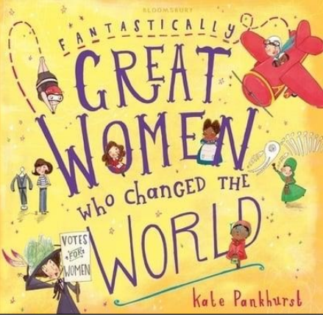 |  | 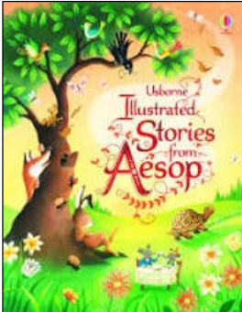 |  | 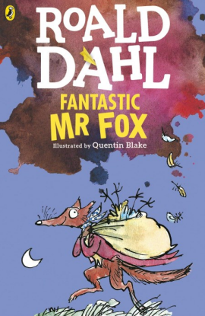
Genre | Non-Fiction – Dreams and Goals |  | Fables - Anthology |  | Fiction
Pupils will know: | A caption is a phrase or sentence which explains the picture.  Sequencing is putting events in the order that they happened.  Tables can provide a structure to summarise a text.  A time conjunction tells us when the action is taking place. |  | The meaning of a synonym.  That empathy is the ability to share and understand the feelings of someone else. |  | Predictions must be based on clues given.  An event is an action that happens in the story.  A bullet point is an organisational device which uses a symbol to indicate separate items.  A strategy for answering multiple choice questions.  A recipe is a type of instruction text.  A location is a particular place (the setting).
Pupils will be able to: | Retrieve information from more than just the main body of text.  Make links between events in a text and their own experiences.  Summarise facts to complete a table.  Determine when events have taken place in the text. |  | Find and retrieve synonyms from the text. Identify and empathise with a character’s behaviour and feelings. |  | Annotate a drawing using evidence from the text read to them.  Sequence events in the order they are revealed.  Retrieve items from a text.  Find the meaning of unknown words using knowledge of context and synonyms.  Retrieve information from a text to prove statements true or false.  Explore links between texts.

