Reading – Year 3
Autumn
Main Text | 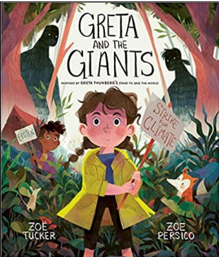 | 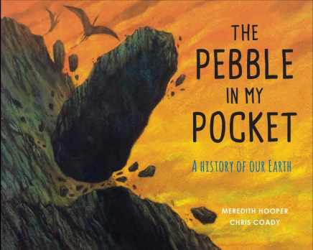 | 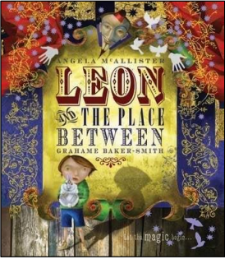 | 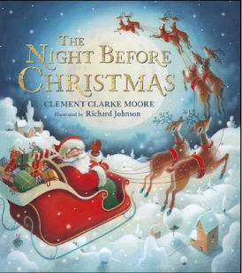
Genre | Fiction – Non-Fiction | Non-Fiction | Fiction | Poetry
Pupils will know: | A summary is a brief overview of a text.  How real events can be presented as a narrative. | Strategies for scanning for retrieval.  The difference between fact and opinion.  How different texts can be organised.  Themes can be represented in different ways. | The differences and similarities between picture and chapter books.  Inference combines evidence from the text and personal experience to make a conclusion.  A theme is a subject or idea that recurs throughout a text.  The difference between stated and suggested information. | Poets use rhythm and language to create effects.  Meaning can be inferred from description and dialogue.
Pupils will be able to: | Retrieve key details by reading closely.  Respond to the core themes in a text. | Identify details from a text accurately and efficiently.  Infer the view of an author from their language selection.  Make connections between what they have read.  Retrieve key details by reading closely. | Draw diagrams to exemplify some text.  Find evidence to support a given inference.  Identify an appropriate theme for a text.  Use clues to interpret the intended meaning. | Comment on poetic effects.  Use inference skills to gain meaning from a range of texts.
Spring
Main Text | 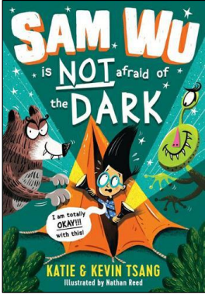 |  | 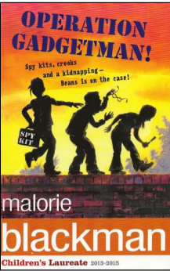
Genre | Fiction – Picture book/Graphic Novel |  | Fiction - Adventure
Pupils will know: | Authors use a range of layout techniques to appeal to the reader.  An inference is a statement based on evidence and reasoning.  The rule of three groups three things together for greater impact. Atmosphere is the overall feeling, emotion or mood created.  That slang is a type of informal language.  A summary of a piece of text is a condensed version that only contains the main points. |  | Foreboding is a sense that something bad is going to happen.  The difference between fact and opinion.  Subheadings guide the reader through the information in a non-fiction text. Authors use descriptive language to create mood.  We compare texts by finding similarities and differences.  Poets use word choice and structure to suggest meaning.
Pupils will be able to: | Describe the effectiveness of a layout technique.  Identify evidence to support an inference.  Identify different literary techniques in a text.  Sequence summaries from a text.  Identify and discuss the effect of informal language.  Interpret notes to organise a text. |  | Explain how an author creates a sense of foreboding.  Empathise with a character.  Use subheadings to retrieve and organise information.  Explain how authors create mood.  Find similarities and differences in fiction and non-fiction.  Infer meaning from poetic devices.
Summer
Main Text | 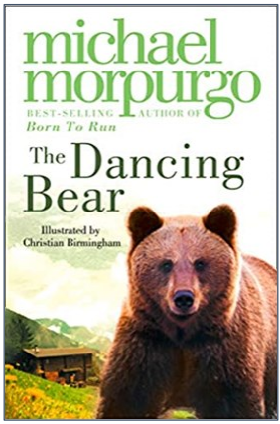 |  | 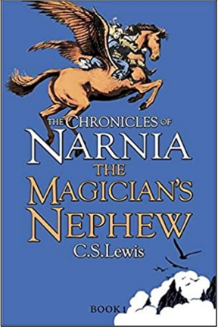
Genre | Fiction |  | Fiction
Pupils will know: | Words can have an emotive effect.  Literary techniques are the different ways language is used to add meaning and impact.  Reading a range of texts increases our knowledge base.  The theme is the underlying message or the big idea of a story.  A topic sentence expresses the main idea of a section of text.  Character development is the process of revealing a unique character with depth, personality and clear motivations. |  | Retrieve means to find and get information from the text.  Texts are written for different purposes.  A genre is a particular type of literature, art, film or music.  A motive is the reason, need or desire that causes a person to act.  The difference between skimming and scanning.  Perspective is the point of view from which the story is told.
Pupils will be able to: | Explain how meaning is enhanced through choice of words. Recognise how different texts use the same techniques to influence the reader.  Draw on multiple texts to expand their views on different topics. Identify themes in a text and compare how texts explore the same themes.  Summarise a text by identifying and simplifying the topic sentence. Infer characters’ intentions. |  | Retrieve key details from the text.  Infer the purpose of a text.  Identify the genre of multiple texts which explore a similar theme.  Explain how a character is feeling from their actions and what they say.  Scan and highlight text to answer retrieval questions.  Draw on different texts to develop a personal view on a theme.

