Reading – Year 4
Autumn
Main Text | 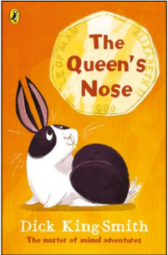 | 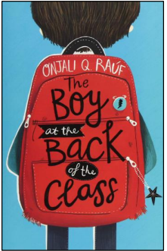 |  | 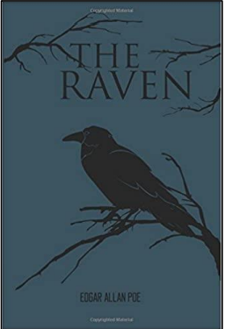
Genre | Fiction | Fiction – A refugee story |  | Poetry - Narrative
Pupils will know: | Question words can provide clues to the type of answer needed.  Key differences between narratives and poetry.  Predictions need to be supported with reference to the text.  Inference can be found both in the clues given and the information that is not given. | A theme is an idea that pervades a whole text or part of a text.  Inferences can be drawn from characters’ actions and behaviour and dialogue.  Shades of meaning refers to subtle differences in the meaning of words.  Authors use language to influence the reader.  Intentions and opinions can be inferred from language choices.  A range of literary devices can be used to emphasise key ideas. |  | Meaning can be inferred from dialogue and descriptive detail.  Poets use language, rhyme and rhythm to create different effects.
Pupils will be able to: | Identify and discuss key themes across texts.  Distinguish between fact and opinion.  Give reasons for their predictions.  Make inferences about the past experiences of characters and the actions of others. | Select specific details from a text to illustrate a theme.  Infer meaning from dialogue and description.  Select relevant details to produce a summary of a text.  Use evidence from a range of sources to support responses.  Use inference skills to explain characters’ motives and opinions.  Identify and explain the impact of literary devices on the reader. |  | Explain the effects of language choices made by the writer.  Infer meaning from dialogue and descriptive detail.
Spring
Main Text | 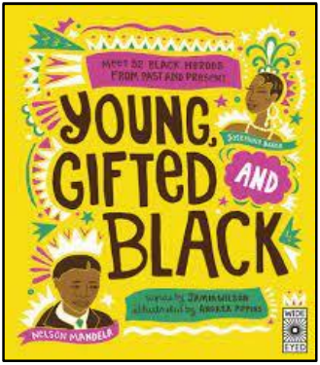 |  | 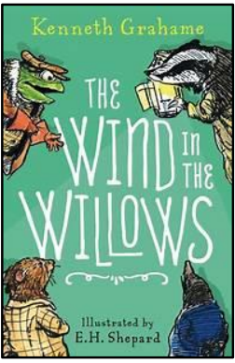
Genre | Non-Fiction – Diversity |  | Fiction - Classic
Pupils will know: | To compare texts means to find similarities and differences between them.  The purpose of a text is the message an author wishes to convey.  Making comparisons means to find similarities and differences.  The difference between stated and implied information.  The opinions of a writer can be inferred from the language they use.  Texts can have a range of purposes and audiences. |  | Poetic devices can be used to express meaning in narrative texts.  Inferences can be drawn from specific details and clues in the text.  A prediction needs to be based on evidence.  The difference between explicit and implicit.  Writers use language to persuade and evoke atmosphere.  What a summary should include.
Pupils will be able to: | Select phrases from a text to prove or disprove a statement.  Select evidence from a range of texts to validate an inference.  Select evidence from a text to justify an inference.  Make valid predictions based on stated or implied details.  Distinguish significant information in a text from supplementary details.  Can identify and describe contrasts in language and tone. |  | Skim and scan texts to locate specific words or phrases.  Find evidence in a text to support a given statement or inference.  Can use inference to prove or disprove a given statement.  Can identify and locate evidence of specific themes in texts.  Retrieve specific details from multiple sources and from across a text.  Select evidence to prove or disprove a given statement.
Summer
Main Text | 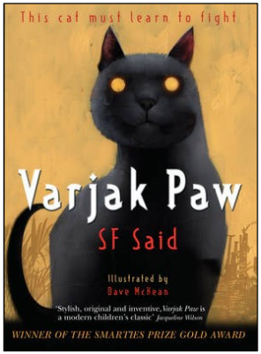 |  | 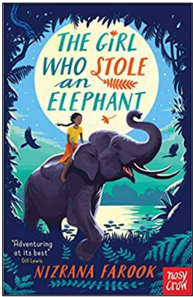
Genre | Fiction |  | Fiction
Pupils will know: | The difference between fact and opinion.  Atmosphere is the overall feeling, emotion or mood created in a narrative.  A point of view is someone’s opinion on a subject.  A review is a text intended to inform the reader about a product or a service.  A strategy for answering multiple-choice questions.  A visual representation is an image, symbol or chart. |  | Authorial intent is what an author intends us to take from their description.  There is no right or wrong answer when providing a personal response to a question.  The difference between skimming and scanning.  Prediction is a form of inference.  The difference between precision and concision.  A perspective is the view that someone holds.
Pupils will be able to: | Use vocabulary to decide whether something is fact or opinion.  Infer the meaning of unknown words from the context.  Retrieve words and phrases that indicate the writer’s point of view. Consider the effect of the choice of words or phrases used by the author to infer the intended meaning.  Use a process of elimination to answer multiple-choice questions. Retrieve key facts to create a visual representation. |  | Explain the image that an author is trying to create based on the language that they select.  Support an inference by drawing evidence from more than one text.  Skim and scan to retrieve details from a text.  Make a reasoned prediction that is rooted in evidence.  Explain the importance of concision and precision in a summary.  Use knowledge of vocabulary and retrieval to construct an inference.

