Reading – Year 5
Autumn
Main Text | 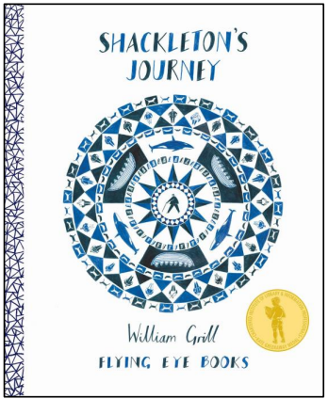 |  | 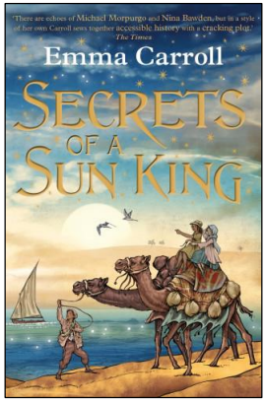
Genre | Non-Fiction |  | Fiction – based on historical content
Pupils will know: | The author’s intent dictates the style of a book.  The language we use changes over time.  Predictions need to be feasible and based on evidence.  The difference between relevant and irrelevant information.  Comparing and contrasting means finding similarities and differences.  Quotations need to be considered in context. |  | A summary is a brief account of the main points.  A story can have more than one narrator.  Interpretations may vary depending on our own experience.  Empathy helps to interpret characters’ actions.  Precision is needed when quoting.  The technique of dropping hints to the reader is called foreshadowing.
Pupils will be able to: | Use skimming and scanning to retrieve.  Use evidence to support an opinion.  Retrieve quotations to prove statements.  Use life experience and empathy to support inference.  Retrieve multiple examples of evidence.  Construct an extended response to explain inference. |  | Use layout features to navigate a text.  Consider the relative strength of multiple pieces of evidence.  Use synonyms to support retrieval.  Explain the impact of word choices on the reader.  Use key question words to support retrieval.  Make inferences from a character’s actions and spoken words.
Spring
Main Text | 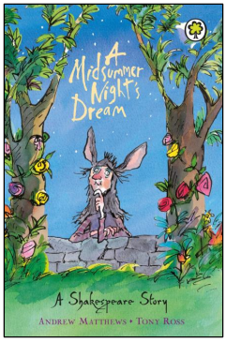 | 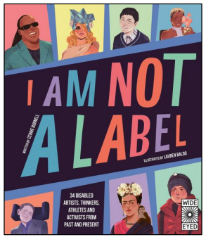 |  | 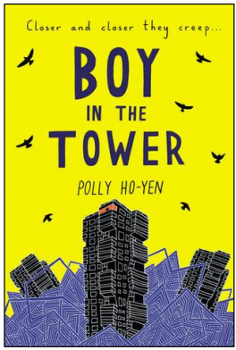
Genre | Fiction – Classic story based on play | Non-Fiction – challenges difference, promotes inclusivity |  | Fiction – Dystopic
Pupils will know: | Answers do not always need to be in full sentences.  The wording in questions may not match that in the text. | The protagonist is the main character in a story, film or play.  Narratives are not always written chronologically.  Some of the misconceptions and prejudices that exist about disability.  The content of a book can shape our attitudes and opinions. |  | Some stock phrases to support interpreting evidence.  A range of techniques used to end chapters and motivate the reader to read on.  A theme is an idea which repeats throughout a work of art or book.  How to structure an oral response to questions.  Pictorial representations can be used to summarise key points.  Archaic language is outdated and rarely used vocabulary.
Pupils will be able to: | Analyse questions carefully to understand what is required.  Summarise a paragraph or longer section of text. | Orally rehearse responses before writing them. Explain how a piece of evidence supports a point.  Use antonyms to support when proving or disproving statements.  Identify superfluous words when summarising. |  | Identify some techniques used in poetry and explain their intended effect.  Use inference to support summarising a paragraph.  Identify red-herring information when answering multiple choice questions.  Distinguish between facts and opinions.  Copy the minimum number of words to make a point when quoting.  Explain an author’s intention in varying a narrative structure.
Summer
Main Text | 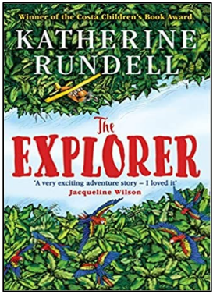 |  | 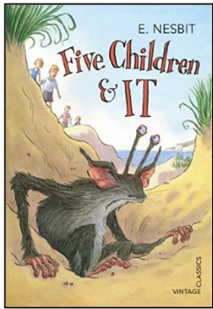
Genre | Fiction – Rainforest setting |  | Fiction - Classic
Pupils will know: | Key words can be used to support inference.  Rhetorical questions can be used as a persuasive device.  Information within non narrative texts is not always factual. Language in a debate is chosen to have impact.  Information in news reports is not always reliable.  Imagery is a literary device to create pictures with words. |  | Humour can be created using vocabulary outside its usual context.  Authors manipulate our response to characters.  Dialogue can convey information about a character.  A theme is an idea that reappears in a work of art or literature.  The spelling and use of language changes over time.  Authors may use stereotypes to portray characters.
Pupils will be able to: | Identify whether a statement is true or false.  Identify key information to use in a summary.  Use evidence to support a prediction.  Draw on text evidence to reach a conclusion.  Scan a text to retrieve specific information.  Distinguish between implicit and explicit information. |  | Use text evidence to make a comparison.  Make inferences about a character based on their actions.  Sequence retrieved information.  Infer the meaning of unfamiliar words using contextual clues.  Distinguish between facts and opinions.  Demonstrate empathy towards fictional or real characters.

