Reading – Year 6
Autumn
Main Text | 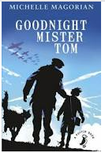
Genre | Fiction
Pupils will know: | The language we use changes over time.  Predictions need to be feasible and based on evidence.  The difference between relevant and irrelevant information.  Comparing and contrasting means finding similarities and differences.  Key words can be used to support inference.  Acquire new language.  Authors manipulate our response to characters.  Dialogue can convey information about a character.  The spelling and use of language changes over time.  Authors may use stereotypes to portray characters.
Pupils will be able to: | Use text evidence to make a comparison.  Make inferences about a character based on their actions.  Sequence retrieved information.  Infer the meaning of unfamiliar words using contextual clues.  Distinguish between facts and opinions.  Demonstrate empathy towards fictional or real characters.
Spring
Main Text | 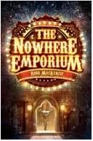
Genre | Fiction
Pupils will know: | Answers do not always need to be in full sentences.  The wording in questions may not match that in the text.  Narratives are not always written chronologically.  A range of techniques used to end chapters and motivate the reader to read on.  How to structure a written response to 3 mark questions.  How to use evidence to support answers.  How to use context to understand new vocabulary.  To understand the effect of punctuation.
Pupils will be able to: | Analyse questions carefully to understand what is required.  Summarise a paragraph or longer section of text. Orally rehearse responses before writing them.  Explain how a piece of evidence supports a point.  Identify red-herring information when answering multiple choice questions.  Distinguish between facts and opinions.
Summer
Main Text |  | 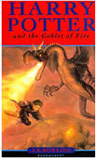
Genre | Non-Fiction | Fiction
Pupils will know: | Interpretations may vary depending on our own experience.  Know that a non-fiction book can be read non-chronologically.  Non-fiction texts can be recorded in different forms. | Humour can be created using vocabulary outside its usual context.  Authors manipulate our response to characters.  Dialogue can convey information about a character.  Authors may use stereotypes to portray characters.  How to make sense of unfamiliar words.
Pupils will be able to: | Distinguish between fact and opinion.  Use evidence to support characters feelings towards an event.  Order events consecutively.  Retrieve and summarise key information from a large portion of text. | Use text evidence to make a comparison.  Make inferences about a character based on their actions.  Sequence retrieved information.  Infer the meaning of unfamiliar words using contextual clues.  Distinguish between facts and opinions.  Demonstrate empathy towards fictional characters.

