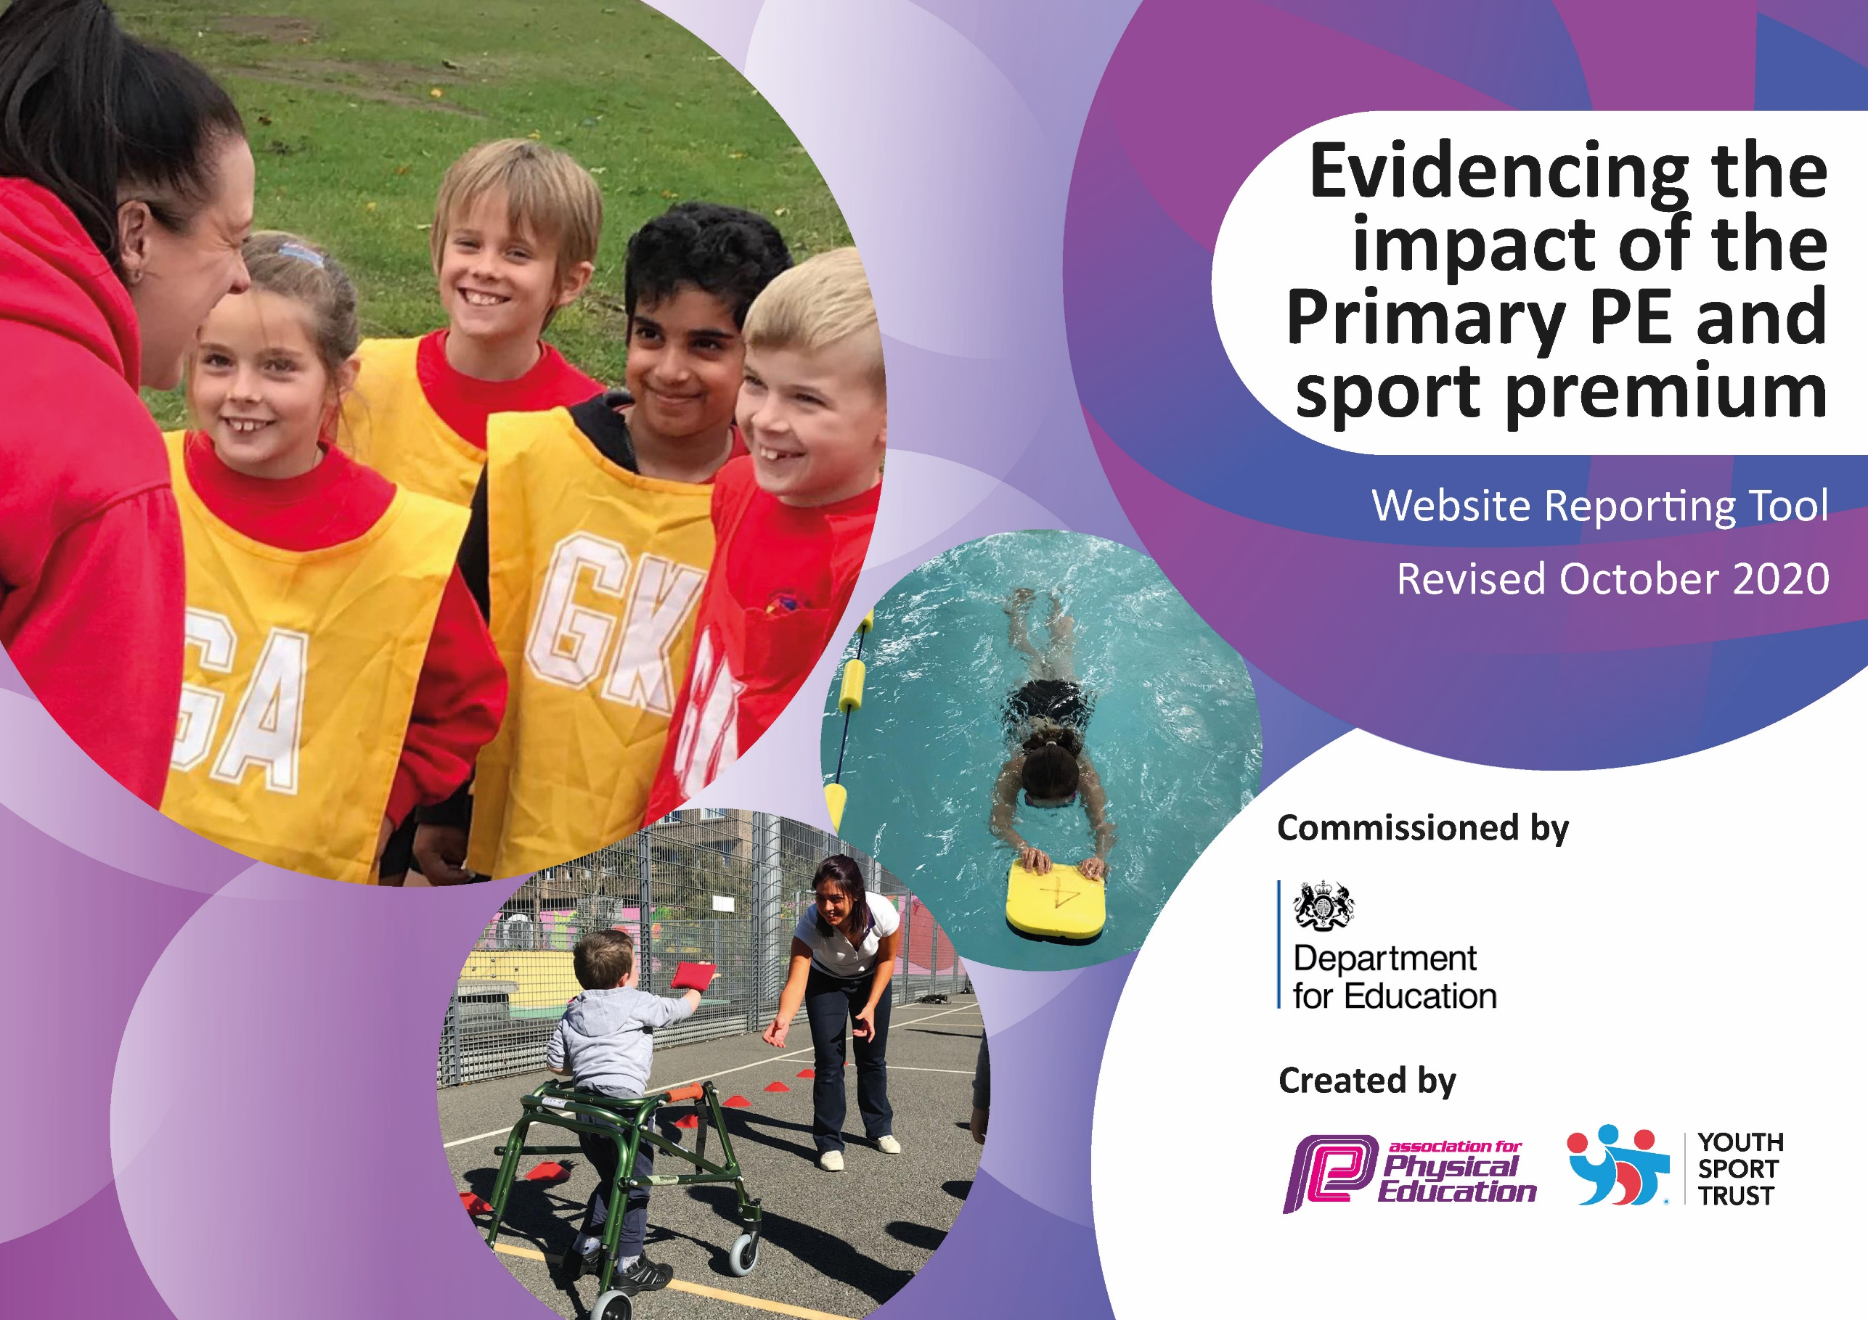

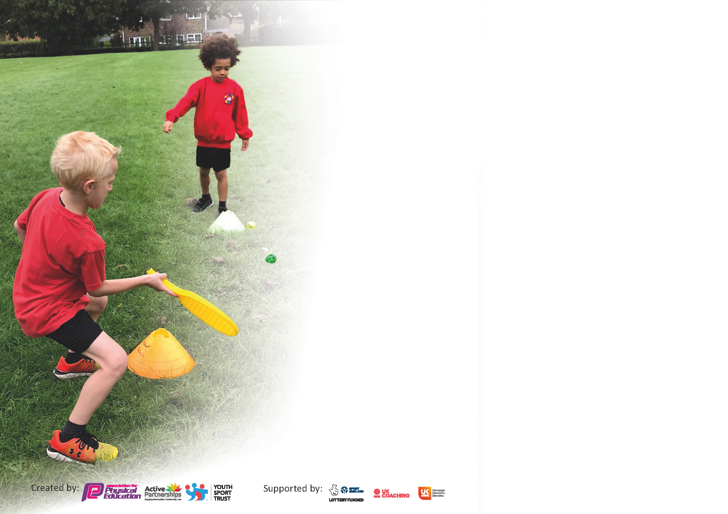

It is important that your grant is used effectively and based on school need. The Education Inspection Framework (Ofsted 2019 p64) makes clear there will be a focus on **‘whether leaders and those responsible for governors all understand their respective roles and perform these in a way that enhances the effectiveness of the school’**.

Under the Quality of Education criteria (p41) inspectors consider the extent to which schools can articulate their curriculum (INTENT), construct their curriculum (IMPLEMENTATION) and demonstrate the outcomes which result (IMPACT).

To assist schools with common transferable language this template has been developed to utilise the same three headings which should make your plans easily transferable between working documents.

Schools must use the funding to make **additional and sustainable** improvements to the quality of Physical Education, School Sport and Physical Activity (PESSPA) they offer. This means that you should use

the Primary PE and sport premium to:

* Develop or add to the PESSPA activities that your school already offer
* Build capacity and capability within the school to ensure that improvements made now will benefit pupils joining the school in future years

Please visit gov.uk for the revised DfE guidance including the 5 key indicators across which schools should demonstrate an improvement. This document will help you to review your

provision and to report your spend. DfE encourages schools to use this template as an effective way of meeting the reporting requirements of the Primary PE and sport premium.

We recommend you start by reflecting on the impact of current provision and reviewing the previous spend.

Schools are required to publish details of how they spend this funding as well as on the impact it has on pupils’ PE and sport participation and attainment by the end of the summer term or by **31st July 2021** at the latest.

# ** In the case of any under-spend from 2019/20 which has been carried over this must be used and published by 31st March 2021.

We recommend regularly updating the table and publishing it on your website throughout the year. This evidences your ongoing self-evaluation of how you are using the funding to secure maximum, sustainable impact. Final copy must

be posted on your website by the end of the academic year and no later than the 31st July 2021. To see an example of how to complete the table please click HERE.

Created by: Supported by:

Please note: Although there has been considerable disruption in 2020 it is important that you publish details on your website of how you spend the funding - this is a legal requirement.

Support for review and reflection - considering the 5 key indicators from DfE, what development needs are a priority for your setting and your pupils now and why? Use the space below to reflect on previous spend and key achievements and areas for development.

N.B. In this section you should refer to any adjustments you might have made due to Covid-19 and how these will influence further improvement.

|  |  |
| --- | --- |
| Key achievements to date until July 2020: | Areas for further improvement and baseline evidence of need: |
| * The Key workers enjoyed daily Joe Wickes sessions. Weekly work sent home included PE activities to ensure the children were encouraged to keep healthy. * Once the children were back in school, half a class at a time, the teachers tried to ensure that this health focus continued and homework was set to support this. The children joined in with the daily mile and scooters for Wheelie Wednesday. * We were due to attain our Platinum award this year and were on track for this but due to COVID we were limited with what we could offer. We received a certificate in recognition of ongoing contribution and achievement in the School Games Programme. * Break time clubs were introduced and continued eg table tennis and speed stacks to ofer a variety o sports activities. * The wooded area was starting to be cleared for outside lessons but has been put on hold but hopefully will be incorporated into orienteering lessons. * Complete PE package used to support lesson planning and assessment | * OAA - wooded area to be used for orienteering and outside lessons. * Swimming lessons were not used in spring 2 for catch up so currently there are children in Year 6 children who need more swimming lessons to ensure they can swim 25m etc. Unfortunately this could not be offered in spring 21. * Achieve platinum summer 2021 * Ensure swimming is a priority for KS2 in Aut 21. * New PE assessment framework to be rolled out across the whole school so all staff use it to support lessons * New Complete PE framework to be reviewed in light of COVID to ensure curriculum requirements met * Get Active Week used to introduce new and healthy active experiences for emotional well being * To provide a wide range of break and lunchtime clubs when possible due to COVID increasing opportunities for children across the school- this has been a challenge as advice not available until end of summer term. |

Did you carry forward an underspend from 2019-20 academic year into the current academic year? YES

If any funding from the academic year 2019/20 has been carried over you MUST complete the following section. Any carried over funding MUST be spent by 31 March 2021.

|  |  |  |  |  |
| --- | --- | --- | --- | --- |
| **Academic Year: September 2020 to March 2021** | **Total fund carried over: £6,859** | **Date Updated: Nov 2020** |  | |
| What Key indicator(s) are you going to focus on?  KI14- Broader experience of range of sports and KI1 – Engagement of all pupils in at least 30mins a day | | | | Total Carry Over Funding: |
| £6,859 |
| **Intent** | **Implementation** | | **Impact** |  |
| Your school focus should be clear how you want to impact on your pupils.  K14 and KI1 Offer break time activities to ensure the children are more active due to lockdown inactivity  Ensure daily mile used to promote exercise and competition across the school  Ensure children know what health is and how they can achieve this through lessons  KI3 training for staff  Playleaders (post COVID) increase positive play at break and lunch with new equipment  2 hours quality PE each week plus daily mile. | Make sure your actions to achieve are linked to your intentions:  Buy playtime equipment and offer table tennis as a club starting with Yr 4 and ensuring Yr5/6 get full use of the table tennis table at break/lunch  Ensure classes have their own play equipment to use at break and lunch to ensure activity and replenish resources when needed due to not sharing.  Use playleaders to encourage active play- should be trained and have a bank of games and equipment.  Check timetables- check register of participation (difficult if can’t mix bubbles) | Carry over funding allocated: £7000  £102.29 cricket  £870 Table tennis  £27.66 chalk  £11.27 skipping ropes  £327 breaktime equip  £208 music box  £110 table tennis extra  £34.47 tubs  £400 replenish playtime equipment  Training £30 gym  Training £20 dodgeball  YST - £300  Platinum BS £1480  Complete PE £126  Equipment checks- gold and repairs - £500 plus £615  £1000 - TA to support staff in lessons each week  Total £7000 | Evidence of impact: The children are improving on daily mile and engaging in lessons  Engagement at break and lunchtimes  Attendance at table tennis  Enjoyment of activities  Teachers feel more supported and able to teach a variety of lessons with the support of a trained specialist.  Year 5/6 pupils given sports leader roles- less incidents and more children physically active. (not currently possible)  Termly log for each class to show increased and sustained participation by all children in lessons. | Sustainability and suggested next steps and how does this link with the key indicators on which you are focussing this academic year?:  Engagement of at least 30mins daily including daily mile, active break and lunch.  Training children each year using current children once bubbles are removed. Music on both playgrounds and update tunes as and when- replace when necessary equipment.  Play leaders visible once bubbles removed, new equipment to keep active breaks fun.  Daily mile logged for weekly competition shows improvement |

|  |  |
| --- | --- |
| Meeting national curriculum requirements for swimming and water safety.  N.B Complete this section to your best ability. For example you might have practised safe self-rescue techniques on dry land. |  |
| What percentage of your current Year 6 cohort swim competently, confidently and proficiently over a distance of at least 25 metres?  **N.B.** Even though your pupils may swim in another year please report on their attainment on leaving primary school at the end of the summer term 2021. | 22/30 currently 73% |
| What percentage of your current Year 6 cohort use a range of strokes effectively [for example, front crawl, backstroke and breaststroke]? | Currently 50% |
| What percentage of your current Year 6 cohort perform safe self-rescue in different water-based situations? | Currently 100%- will be doing class based lessons to support this throughout the year. |
| Schools can choose to use the Primary PE and sport premium to provide additional provision for swimming but this must be for activity **over and above** the national curriculum requirements. Have you used it in this way? | Yes/No  No child has been able to use the local pool this year |

**Action Plan and Budget Tracking**

Capture your intended annual spend against the 5 key indicators. Clarify the success criteria and evidence of impact that you intend to measure to evaluate for pupils today and for the future.

|  |  |  |  |  |
| --- | --- | --- | --- | --- |
| **Academic Year:** 2020/21 | **Total fund allocated:** £17840 | **Date Updated: May 2021** | |  |
| **Key indicator 1:** The engagement of all pupils in regular physical activity – Chief Medical Officers guidelines recommend that primary school pupils undertake at least 30 minutes of physical activity a day in school | | | | Percentage of total allocation: |
| 50% |
| **Intent** | **Implementation** | | **Impact** |  |
| Your school focus should be clear what you want the pupils to know and be able to do and about  what they need to learn and to  consolidate through practice: | Make sure your actions to achieve are linked to your intentions: | Funding allocated:  £9,000 | Evidence of impact: what do pupils now know and what can they now do? What has changed?: | Sustainability and suggested next steps: |
| Daily mile at least 3xs per week extra to PE lessons- aiming for 5  Break time equipment used to ensure children are active  Resurface the top playground and put on playground markings and new traversing wall to top playground (awaiting markings)  Reintroduce playleaders when COVID secure (not able to as of May 21)  Playleaders (post covid) to be trained and used to support play at break and lunch  2 hours of quality PE per week to continue  Member of staff to train play leaders- resources ordered to ensure active breaks | Playleaders trained to support play at break and lunch (unable to cross bubbles)  New equipment used to support breaks and lunches to be active (lots more bought as each bubble have their own)  MUGA traversing wall repaired and design top playground to include one.  Daily Mile Competition for each class to travel around the world with daily mile  Playground markings-   * track around outside * Basketball posts and markings * Hop scotch * Dance zone * Spots for different shooting pace   Introduce gonoodle, cosmic yoga, PE with joe wickes, imoves | New resources  £1000  Freshair fitness checks £600 per anum  Spare scooters - £120 for Yr 1/2  Scooter racks £550  Repair of traversing wall in MUGA  £4000  Playground resurface- £3000 | Ensure all children can run 5 times around the track- improved fitness logged  Termly physical log of participation to identify different active and non-active pupils to show improvement  Variety of skills developed with the variety of playtime equipment including climbing facilities- -logged physical improvement  Traversing wall repaired and new one built which the children are enjoying at break and lunch  Daily mile competition used on a Friday assembly to encourage participation  Playground resurfaced at top and awaiting playground markings  Scooter racks installed for the Yr1/2 children to use for safe storage | Playground surface done and awaiting playground markings for KS2 playground- wet weather has halted this  MUGA traversing wall can be used safely and newly installed one on top playground  Daily mile/scooter track needs markings each year  Spare scooters used for children who forget/don’t have one  Playleaders have been lacking this year due to no mixing of bubbles.(needs to be in place for next year)  Children have continued to have 2 hours of PE each week. Playground markings and basketball hoops needs to be in place asap. |
| **Key indicator 2:** The profile of PESSPA being raised across the school as a tool for whole school improvement | | | | Percentage of total allocation: |
| 5% |
| **Intent** | **Implementation** | | **Impact** |  |
| Your school focus should be clear what you want the pupils to know and be able to do and about  what they need to learn and to  consolidate through practice: | Make sure your actions to achieve are linked to your intentions: | Funding allocated:  £1000 | Evidence of impact: what do pupils now know and what can they now do? What has changed?: | Sustainability and suggested next steps: |
| The whole school competition of daily mile used to ensure the classes are competing to do at least 15mins activity  To compete in virtual competitions whilst COVID reduces the amount we can do  Ensure intra competitions are reintroduced as quickly as possible and then inter school competitions  Scooter training for Year 1 and 2 each year so that the track can be used safely on Wheelie Wednesday    Sports week well attended by Yr1-6 at Stanborough and Skreens Park  PE boards in hall and in dining hall celebrate PE achievements  Sports captains used to promte intra and inter sports and feedback on assemblies/website  Apply for platinum award 2021 | To use the daily mile as a vehicle of improvement and announce this each Friday assembly  Spare scooters procured so that children who forget can use these.  Encourage active playtimes with lots of class equipment  All children attend either a wet and dry activity alternatively to increase their range of sports activities  Ensure Year 6 sports captains feedback in assemblies  Ensure boards and website is updated regularly  Staff volunteer to keep clubs going. Extra clubs eg Hiphop and gymnastics are paid for by parents with support for PP children  Children aware that their contributions support the application of the award | £200  £600  £200  £200 | Winners notified each week and a noticeable improvement and enjoyment  Virtual competitions entered and achieved eg Year 3 and 4 multiskills Autumn 20 came 1st and 2nd.  Children have participated in a wide range of Outdoor activities throughout their time  Children more aware of sporting events and clubs available. Increased desire for children to participate.  Sports captains talk about their roles and how they have supported to raise the profile of sports and PE  The application is used to show what we have achieved | Continue to promote success and attendance of competitions ensuring everybody participates each year.  Children are all supported to attend PE week activities  Sports leads help to keep the boards updated.  Continue to offer free clubs across Key stages  Sports captains have had little chance to increase their role this year due to not being at school through lockdown and no mixing of bubbles.  The children have not been moving around school so boards have not been updated although mention is made during assemblies as and when necessary. Gaelic football and handball coaches have been used in the summer to increase the profile of sport  Platinum award achieved and continue to build on this |

|  |  |  |  |  |
| --- | --- | --- | --- | --- |
| **Key indicator 3:** Increased confidence, knowledge and skills of all staff in teaching PE and sport | | | | Percentage of total allocation: |
| 5% |
| **Intent** | **Implementation** | | **Impact** |  |
| Your school focus should be clear | Make sure your actions to | Funding | Evidence of impact: what do | Sustainability and suggested |
| what you want the pupils to know | achieve are linked to your | allocated: | pupils now know and what | next steps: |
| and be able to do and about | intentions: | £1000 | can they now do? What has |  |
| what they need to learn and to |  |  | changed?: |  |
| consolidate through practice: |  |  |  |  |
| Training for staff on dodgeball and gymnastics by specialist lead  Be-Netball introduced  Support by the trained PE specialist to support lessons- use of YST to support training for individuals  Introduce pe assessment through complete pe scheme to support learning and a structured approach  Online PE conference to accessed by all staff to support teaching skills and regular CPD to be attended by specialist and feedback into lessons to support teachers  BSP provide specialist coaches with new activities | Teachers have planned time to work with specialist teacher throughout the year to improve their skills  Teachers access good online training via YST  All staff use complete PE package and assessment and supported by PE lead to track progression  Staff identify gaps to support future learning  Specialist teacher and others attend CPD and feedback | £1000  Conference £300  BSP fee  YST fee | Pupils have been supported in a variety of activities with well trained staff.  Assessment criteria successfully used and staff demonstrate confidence and knowledge in areas of PE  Plans used show structure and variety | Continue to train staff (especially new to school) on activities that the teacher audit suggests need support in  Data uploaded termly to ensure progress  Conference attended virtually by more staff to increase confidence and skills.- PE lead attended  PE teacher used time to increase skills via zoom. PE lead where possible has disseminated. Continue to do.  Due to staff absence it has been difficult to have PE lead work with teachers to upskill them this year so will ensure this is in place next year. Assessment has been used to inform reports but when the scheme is not followed this does not allow variation in the assessment. |
| **Key indicator 4:** Broader experience of a range of sports and activities offered to all pupils | | | | Percentage of total allocation: |
| 30% |
| **Intent** | **Implementation** | | **Impact** |  |
| Your school focus should be clear | Make sure your actions to | Funding | Evidence of impact: what do | Sustainability and suggested |
| what you want the pupils to know | achieve are linked to your | allocated: | pupils now know and what | next steps: |
| and be able to do and about | intentions: | £5000 | can they now do? What has |  |
| what they need to learn and to |  |  | changed?: |  |
| consolidate through practice: |  |  |  |  |
| Additional achievements:  Buy resources to cover all the sports to ensure all class can access the whole range of sports within Complete PE  Wider range of sporting activities provided  Sports week to ensure work covers wellbeing  Additional training for those children attended BSP competitions  Local sports clubs used to promote sport and participation eg karate etc  Ensure pp children attend clubs and competition activities where wanted  Ensure more Year 6 children leave school having achieved basic swimming standard | Buy more resources so that the children can access a wide variety of sports in a covid friendly way.  Ensure storage facilities allow the resources to stored safely.  All staff and children to take part in wellbeing focus during weeks including mindfulness eg yoga and healthy eating  PE lead to contact local clubs and liaise with timetable to ensure all children get the chance to participate in varied activities or know about local ones  Children to access swimming when COVID friendly- classroom based activities support the teaching of swimming safety. | £5000 | The children have wide range of resources for break and lessons that introduce them to a wide range of sports when possible  Register shows that all children have attended intra and inter competitions and clubs both in school and out of school- breakdown of participants include SEND and PP children  Links to local sports clubs improve participation  Successful sports week includes mindfulness and wellbeing  Specialist teaching offered across the school once COVID is over | The resources are stored well so will last.  Link with local clubs/parents to increase coaching opportunities  Sports leaders used to support wellbeing activities throughout the year.  BSP membership ensure specialist teachers are available including chance to shine and dodgeball  It has been difficult as all clubs were closed due to COVID as they start to open in end of summer term then links will increase and swimming reintroduced. This will be important at the start of Aut 21 |

|  |  |  |  |  |
| --- | --- | --- | --- | --- |
| **Key indicator 5:** Increased participation in competitive sport | | | | Percentage of total allocation: |
| 10% |
| **Intent** | **Implementation** | | **Impact** |  |
| Your school focus should be clear | Make sure your actions to | Funding | Evidence of impact: what do | Sustainability and suggested |
| what you want the pupils to know | achieve are linked to your | allocated: | pupils now know and what | next steps: |
| and be able to do and about | intentions: | £2000 | can they now do? What has |  |
| what they need to learn and to |  |  | changed?: |  |
| consolidate through practice: |  |  |  |  |
| Virtual competitions 3-6  5/6 football skills  3/4 multi skills  Speedstacks for Yr 4 £500  Mats-consortium p866- £75 x 10 £750  Intra school and inter school competitons  School Games week to include wellbeing activities  Football, tag rugby, Gaelic football and netball etc competitions re-engaged with once COVID safe  Table tennis and speedstack clubs used in Autumn term to reignite competitions for Year 3 and 4.  Ensure a safe way to get children to competitions eg coach hire where possible | More competitive sports both intra and inter will be used.  Ensure any BSP competitions are entered both virtually and in person  Eg multiskills Yr 4 and 3 Autumn term- all entered and Yr 4 came 2nd and Year3 came 1st against BSP schools  School Games day includes carousel of events plus traditional events with sports leader to help. Gym and dance club to entertain at picnic break. Final house relay ends events.  School continues to sign up for platinum package and make good use of every opportunity.  Office to continue to liaise with parents re club participation  Look at cost effective way to get children competitions without overreliance on parents | £2000 | The children enjoy participating to improve upon their own score as well as to compete against others  Register taken to ensure all children participate in intra and inter school games  Increased participation by children in competitions including cross country  School Games support the values of participation so everyone feels valued  Children active at lunch and break and use new skills eg table tennis when possible | All children have continue to participate in sports competitions within school and across schools- competitions within class have increased as restrictions have reduced but no inert school competitions have occurred except virtually.  Dedicated board used to promote competitions and school games- this will be reintroduced in Aut 21 as restrictions reduce.  Playleaders and sports captains help across the school- this has been difficult due to mixing of bubbles- as restrictions ease these will be reintroduced.  Sports Games Day will hopefully be used even if class by class to gain points for their team.  Competitions to be looked at from Aut 21 |

|  |  |
| --- | --- |
| Signed off by | |
| Head Teacher: | M J West |
| Date: | May 2021 |
| Subject Leader: | C Clayden |
| Date: | May 2021 |
| Governor: | C Sharples |
| Date: | May 2021 |